Name: Ademuwagun Ezekiel Adewumi

Course: Cybersecurity

Monitor Network Traffic

I was able to use wireshark to capture and analyse network Traffic

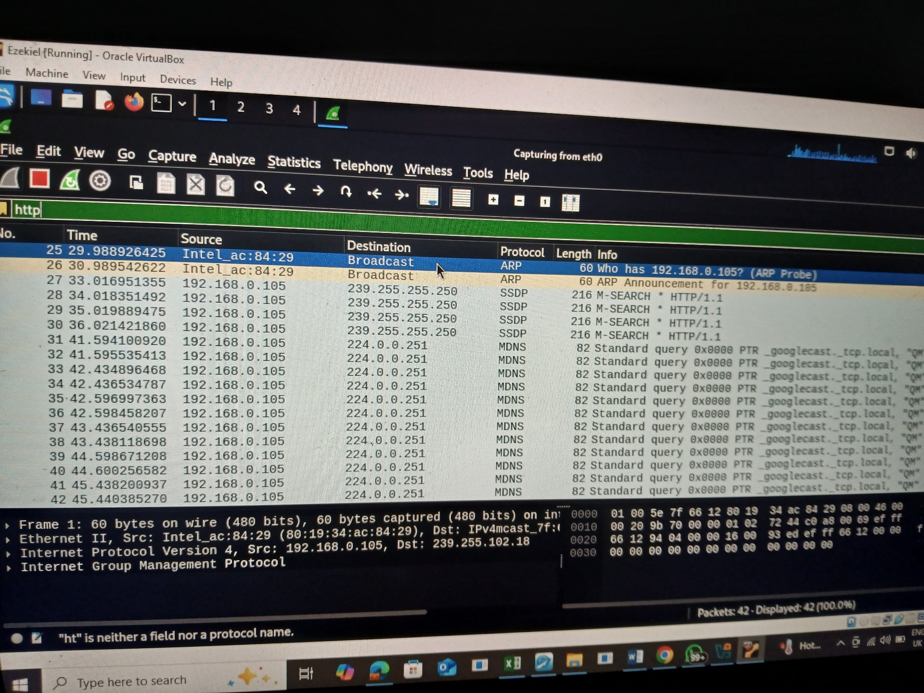

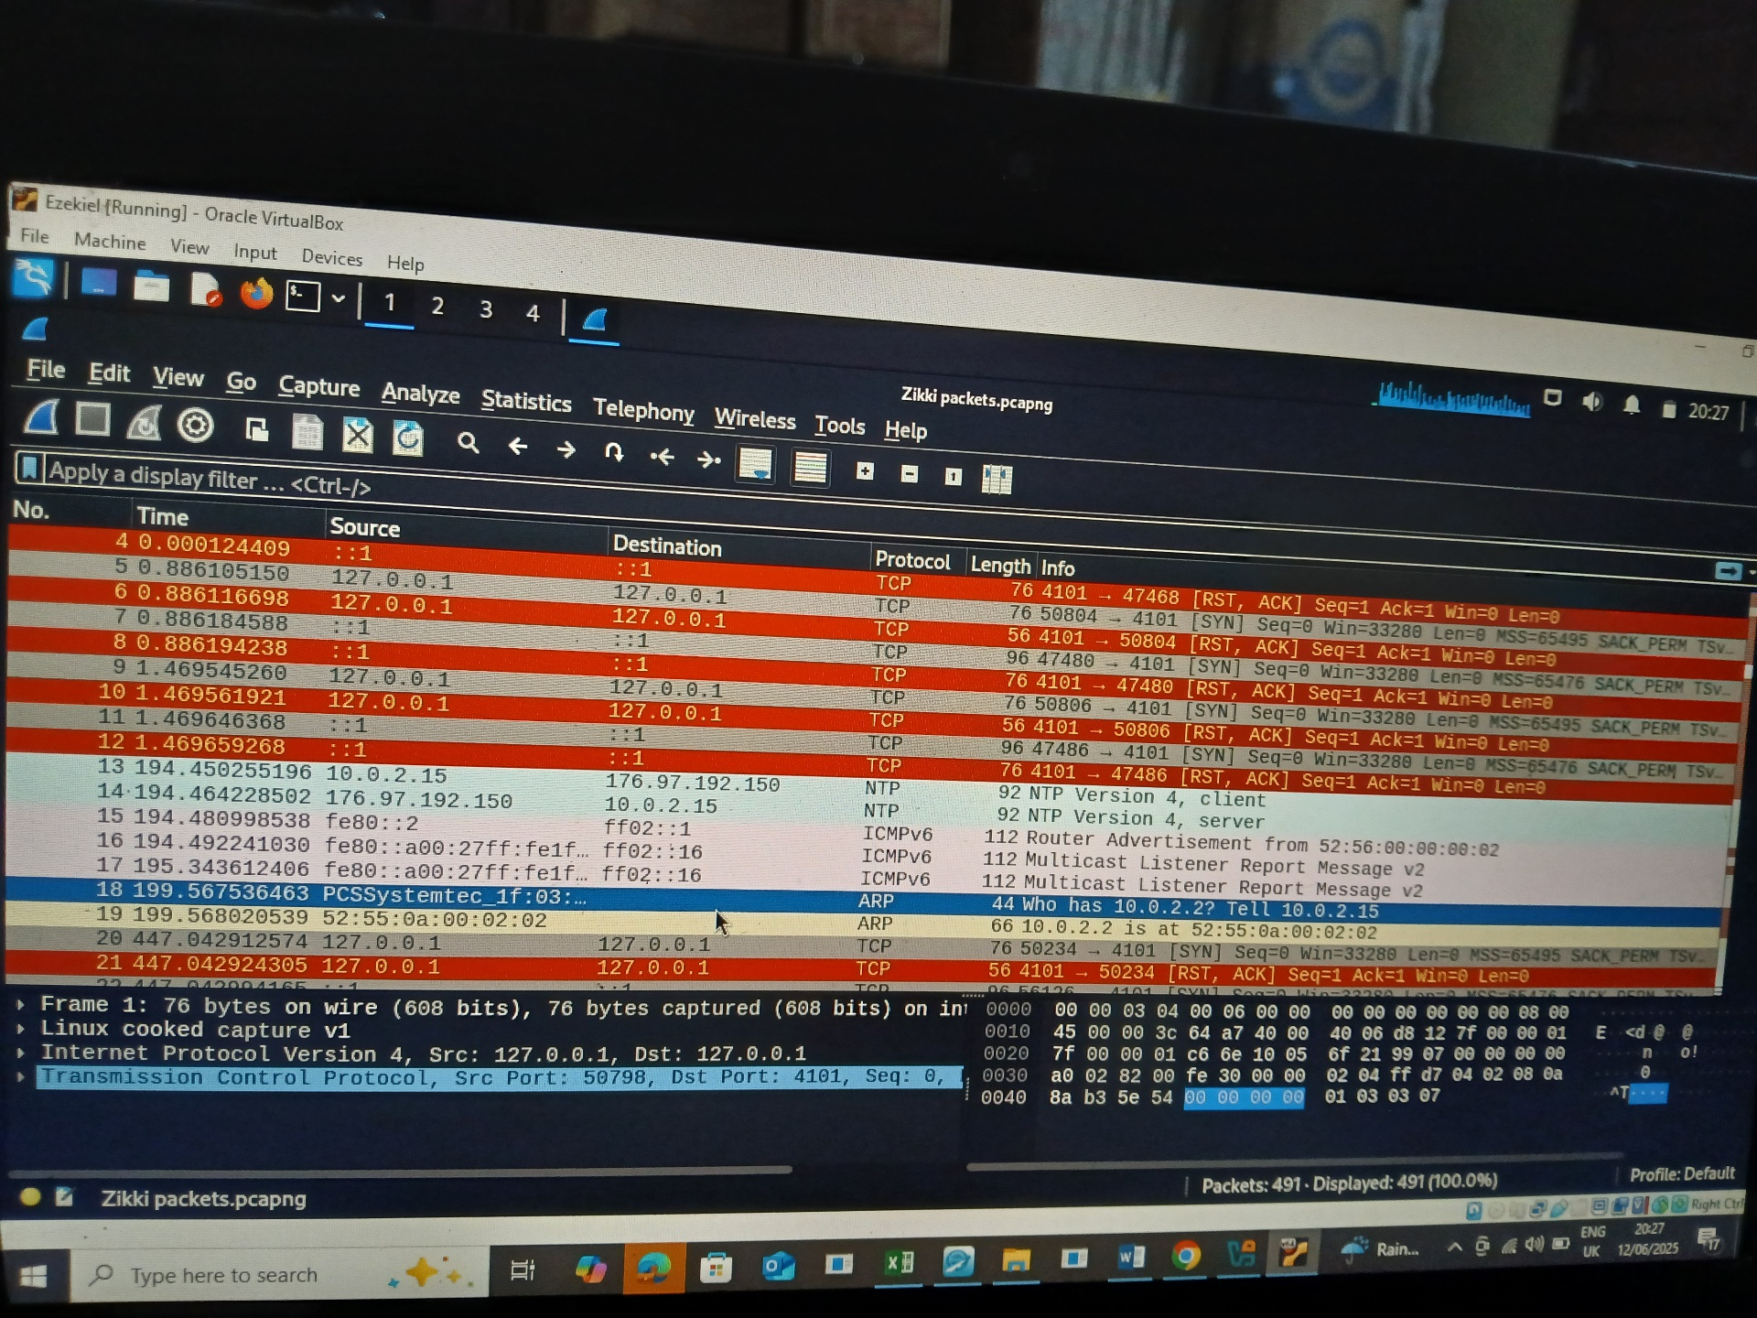

I was able to identify HTTP(login attempts)

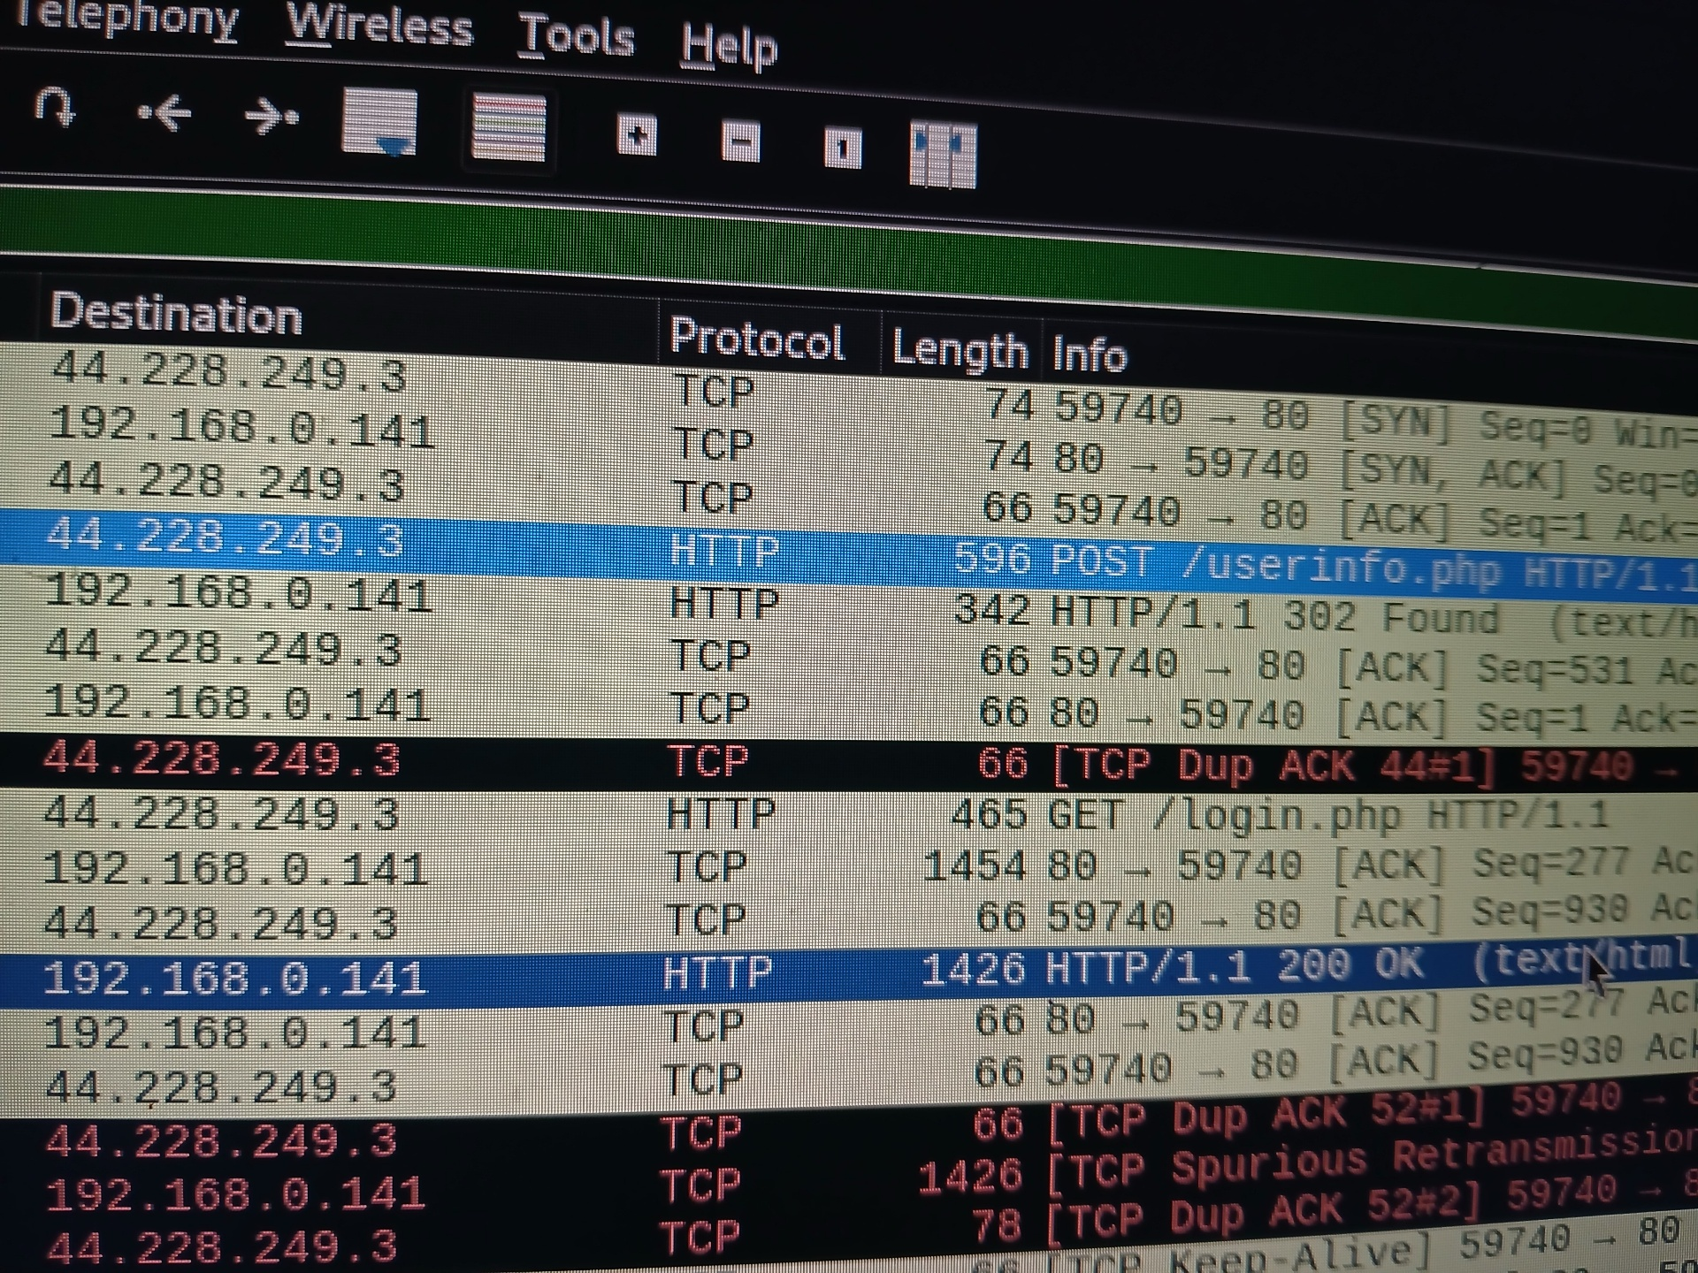

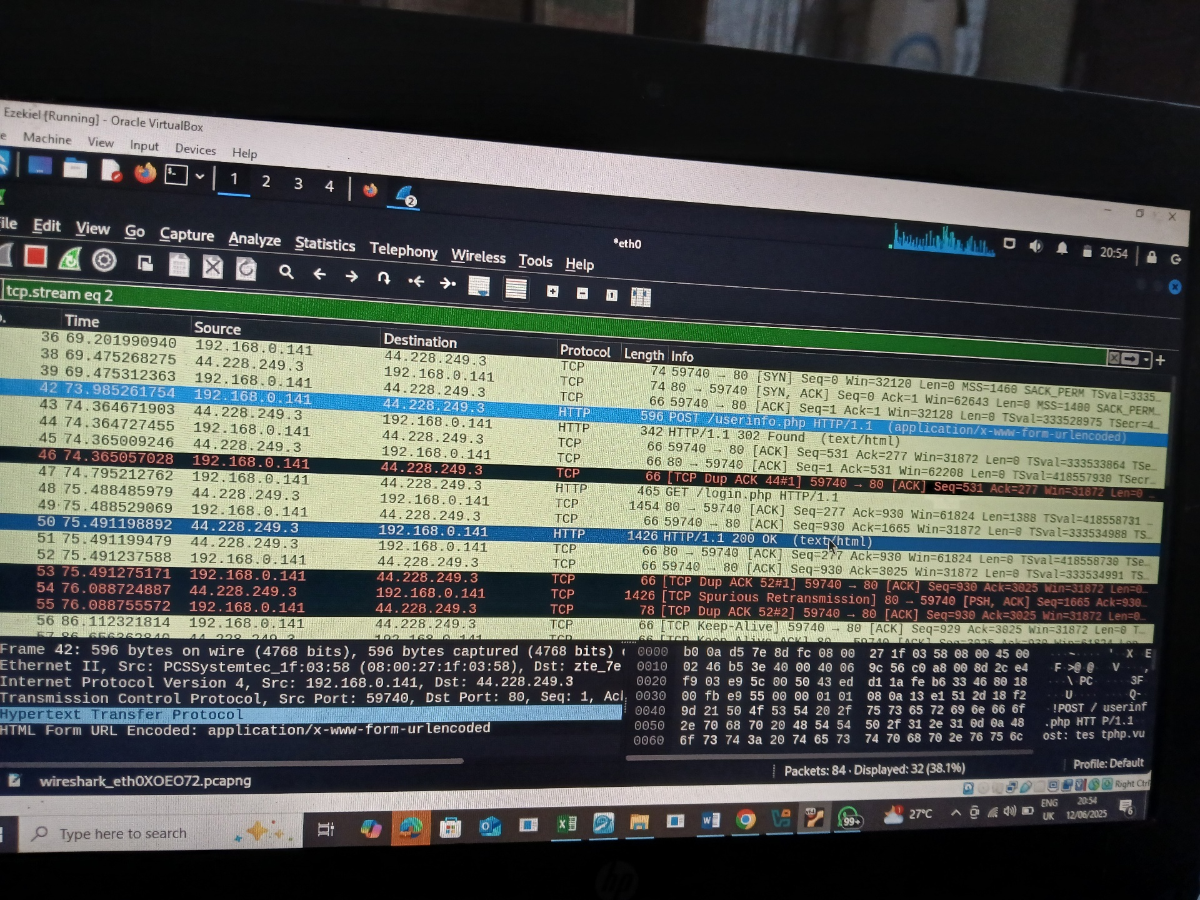

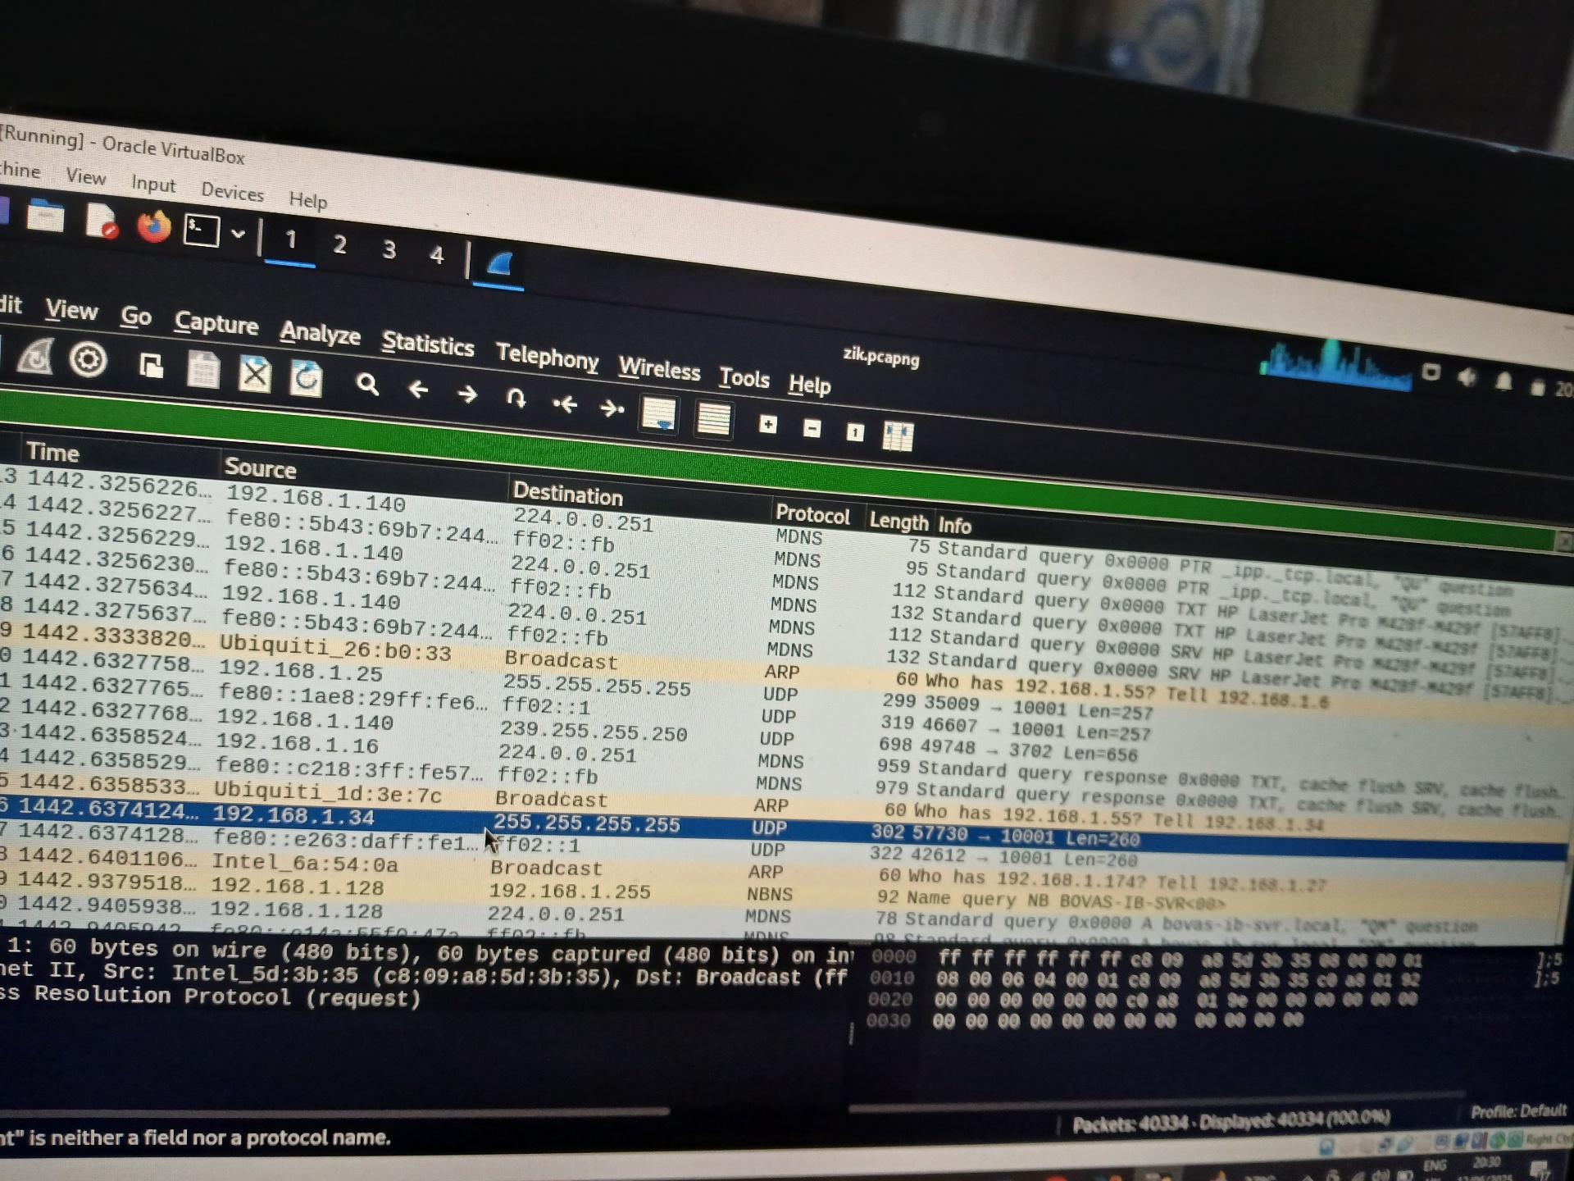

I was able to analyzed the HTTP by checking out for the login details

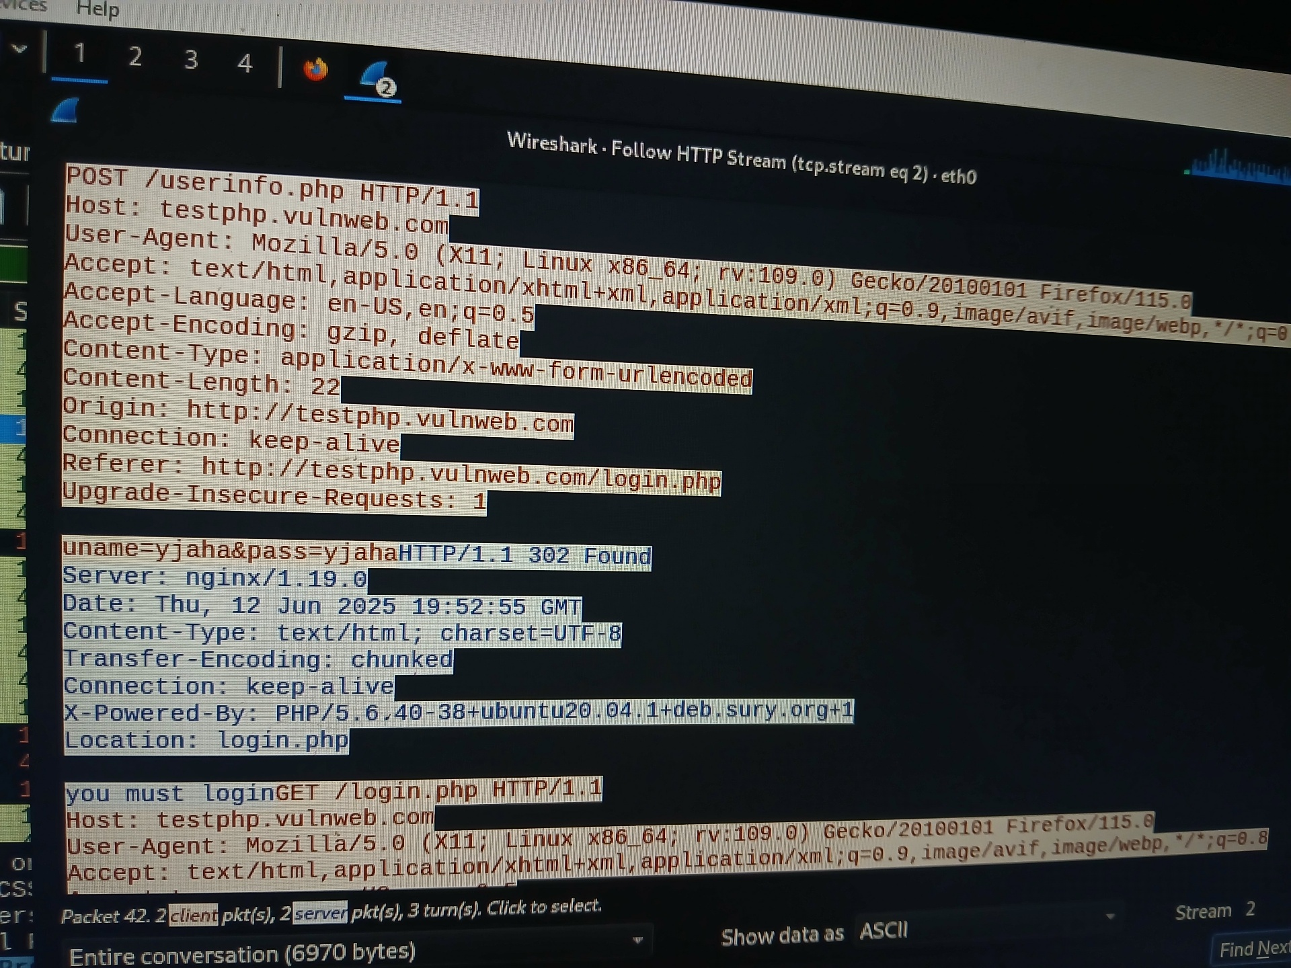

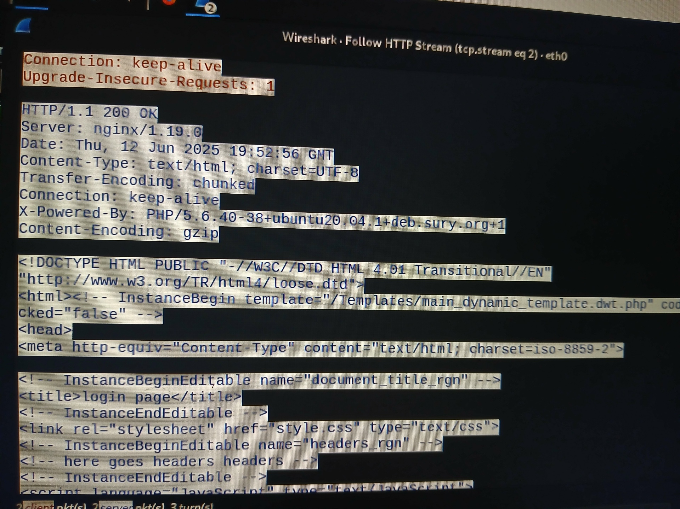

Basic security helps to really check what is going on networks to avoid attackers.

Reflect on security best practices

Below are other ways security measures

could be implemented in a larger ways

1. Centralize logging and SIEM

2. Identify and Access Management (IAM)

3. Intrusion detection and prevention system(IDS/IPS)

Educating other in the importance of network security

To help others stay safe online, I break down network security into simple, everyday topics they can relate to. For example, I teach the importance of strong, unique passwords and encourage the use of password managers. I explain phishing using real examples, like fake emails pretending to be from banks, and show how to spot suspicious links. I also talk about the risks of using public Wi-Fi

without protection, and why enabling multi-factor authentication adds an extra layer of safety